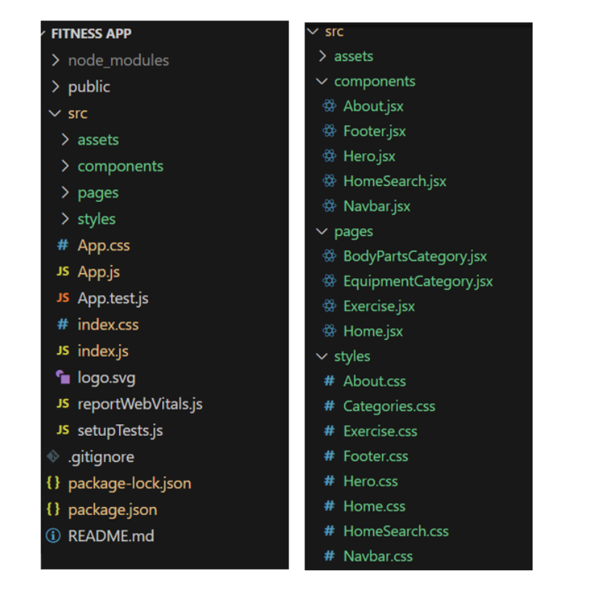

In this project, we’ve split the files into 3 major folders, *Components, Pages and Styles.* In the pages folder, we store the files that acts as pages at different URLs in the application. The components folder stores all the files, that returns the small components in the application. All the styling css files will be stored in the styles folder.